Back in those days, people were having all the time necessary for them to wash their clothes. Some took several hours to wash very few clothes. But this is not the case in our busy world of today. Today, both men and women are too busy to carry out such a time consuming task. Even the children are always occupied with studies. This is to say that everyone from father to child is always on the run, yet they need to dress in clean clothes;
- When they have professional meetings;
- When they have to attend business meetings;
- When they are going for any national or international meeting;
- When they want to partake in parties;
- When they have to go on vacations;
- When they want to go shopping; and
- When they want to carry out their daily occupations.
Yes of course it is possible to carry out all your normal and daily busy activities in clean clothes thanks to the best liquid laundry detergents that we shall review for you. The merely increase your washing experience. They reduce your washing time, and keep your clothes clean, shiny, smelling well, long lasting, and appealing to eyes.
Of course it is normal that you ask yourself why you should pick out a liquid laundry detergent whereas you have been using some other detergent in the past. You can as well ask yourself why you should pick among the best liquid laundry detergents while there are other detergent types in the market. It is true there are several other laundry detergents in the market, but can they meet up your cleaning expectations? Can they combat and stand victorious before the headiest stains caused by chocolate, tea, ground, mud, food, and juice? You can already be sure that our best liquid laundry detergents that we hereby present to you will meet up with all that without any failure.
The liquid laundry detergents were carefully formulated and adjusted over several years to completely dissolve in water which is not the case with all laundry detergents. Thus with them, you can be sure that they won’t accumulate in the textile fibres of your pretty nice and special clothes as it is the case with some none liquid laundry detergents. Several people who have had to use certain powder laundry detergents did notice that it often those not dissolve fully. It is often not rinsed fully from the fibres thus later causing irritations to the highly sensitive skins of her consumers. Nevertheless, you need not worry at all, merely lean back on your wheel chair and rest because our review will put an end to such unbearable situations.
For the past years, several consumers of dusty laundry detergents often complained of allergic reactions caused by these dust particles during the dosage process. It is not the case with the liquid laundry detergents since they are not dusty.
The best liquid laundry detergents that we hereby present to you are favourable to the long lasting of your washing machine. This is because they do not contain hard ballast substances that can accumulate in the machine and work against its efficient functioning capacities.
Liquid laundry detergents often come already dissolved in high concentrations in order to offer to you the best washing experience you’ll ever have.
In addition, the liquid laundry detergents are of higher efficiency because they are water-soluble in nature.
Laundry tips
Whether it is your child’s favourite blanket or it is your best t-shirt, the best laundry detergent will keep it clean, fresh, good looking and long lasting. Consider the following tips to get the best out of your laundry detergent and washing machine:
- It is advisable to clean your washing machine twice a year;
- Always add the detergent before adding clothing when using a top loading laundry machine, this will allow for proper dissolvent;
- Always make sure that you use the correct type of laundry detergent that best suits your washing machine; and
- Always respect the manufacturer’s instructions in measuring the proper quantity of detergent. This will not only lead to effective cleaning but it will also prevent over foaming thereby maintaining your washing machine in good conditions for long.
Have you ever had the experience of leaving cakey white gunges in your garments and clothes after carrying out laundry? This situation is often caused by certain powder detergents that you used. It is high time that you exchange your powder laundry detergent with liquid laundry detergent in order to get the best results. This is because white gunges are prevented when your clothes are washed with liquid laundry detergents. In addition, it functions very well in removing all the stains and grease on your clothes without allowing the even the least residue. Simply have a view at the following leading detergents in order to pick out the best of your choice for the household use.
Liquid detergent reviews: The Persil ProClean
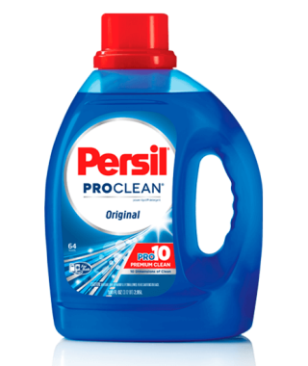
Above is our overall best liquid laundry detergent. Even though it mere entered the U.S during the years 2015, it has been the best seller all over Europe due to its ability to properly clean all luxurious clothes. It leaves them with a pleasant smell, it eliminates all stains in them. It eliminates the unbearable odours that clothes can likely have. The Persil ProClean is what crossed over the oceans to take over power from Tide liquid detergents which were top leading in the market. Although it turns to be difficult to figure out the main differences between these liquid laundry detergents with the mere eye, it is still possible to do so after a long term of use. Your clothes will still maintain their original shinny colour and pretty nice scent. This also turns out to be the editor’s choice.
Pro:
- Best seller;
- Unbearable odour eliminator;
- Efficient in cleaning stains; and
- Freshens and enhances the well-being of your clothes.
Cons:
None.
Customer reviews
It is averagely starred 4.4/5 by her customers on amazon for its efficiency in cleaning. It features several positive customer reviews and only a few negative customer reviews. Several customers upon using it attested that this was the best liquid laundry detergent that they have ever encountered. They were pleased with its cleaning ability, odour elimination ability, and value for money. Nevertheless, some few customers although were pleased with its cleaning capacity still were not pleased with its powerful odour. They complain that it is overpowering.
Reviews of liquid Laundry detergent: Dreft Stage, Newborn Liquid detergent
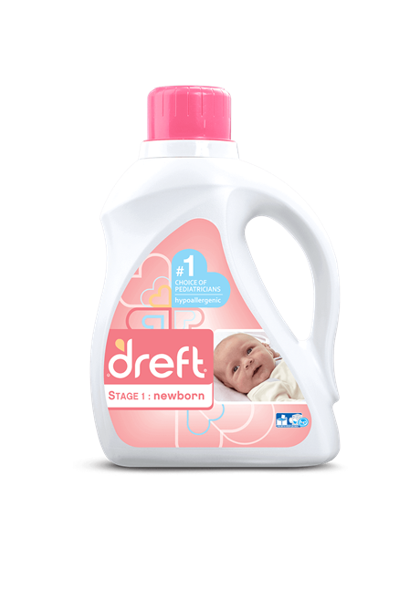
This is a particular liquid laundry detergent that was formulated and brought out for the new born babies. It was carefully designed to be able to clean all fabrics while being soft and gentle on the baby’s skin. For more than 80 years today, this has been the number one choice for several caring mums. It is tough to remove stubborn stains while softening hands thanks to its drefthypoallergic formula.
Pros:
- Easy to use;
- Powerful;
- Great product;
- Efficient for years;
- Convenient;
- Simple user instructions; and
- Baby care.
Cons:
- A little costly.
It features a standard container size that will keep you covered for up to 64 full loads. Worth noting is that this baby detergent works both in standard and high efficient washing machines. However, you are free to use dreft products with any kind of washing you possess.
Customer review
For over 80 years today, several moms who care much for their kids have been using this detergent and have found it trustworthy and efficient. They attest it to be a highly formulated baby detergent.
Reviews of liquid Laundry detergent: Purex Mountain Breeze Laundry Detergent
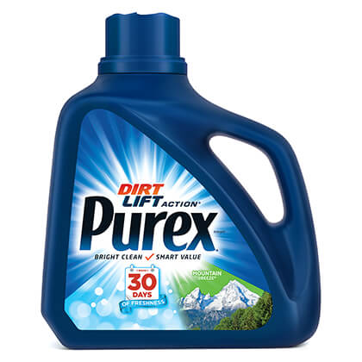
This is a well and specially formulated liquid detergent that was designed with aim of combating the most stubborn stains and dirt in clothes such as food stains, grease, and grass stains. Your cloths are guaranteed to always remain clean and fresh.
Pros:
- Dye-free;
- All purpose for everyday;
- Hypoallergenic;
- Stain fighting;
- Unscented; and
- Brightens cloths with its dirt lift action.
Cons:
- None.
Customer reviews
This efficient laundry detergent is starred 5.0/5 in laundry detergent reviews on Amazon. One of her consumers reported to be highly impressed with it as it made it up to his expectations.
Reviews of liquid Laundry detergent: Wisk and Deep Clean Liquid Laundry Detergent
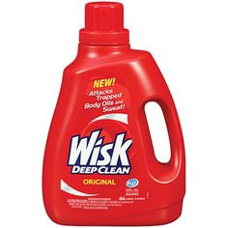
Formulated to deep penetrate inside your fabric and offer to you the best results in terms of cleaning. It cleans even beyond all visible stains. It seeks out and removes all trapped sweat alongside body oils in the clothes. Featuring an outstanding cleaning power, this is the best to purchase to maintain your clothes fresh and free from stains. In addition, it is not only safe to use but it is highly efficient.
Pros:
- Removes all stains;
- Inexpensive;
- Outstanding cleaning; and
- Works well in cold or hot water.
Cons:
- Low availability.
Customer reviews
In laundry detergent reviews on Amazon, this detergent is starred 3.3/5 for effectiveness. In addition, it also features several positive customer reviews alongside some few negative customer reviews.
A good number of customers after using this product attest that it is the best and that they will remain faithful to it. They highly appreciate its scent, cleaning ability, stain combating capacity, and its ability to freshen clothes.
However, some others report negatively about this product as they complain of a feeling that they were robbed. In addition, they believe this product should be starred 1/5 for effectiveness. They say on looking at the label they nearly believed it was original wisk, but it was not long that they felt disappointed.
Reviews of liquid Laundry detergent: Eco Me Liquid Laundry Detergent
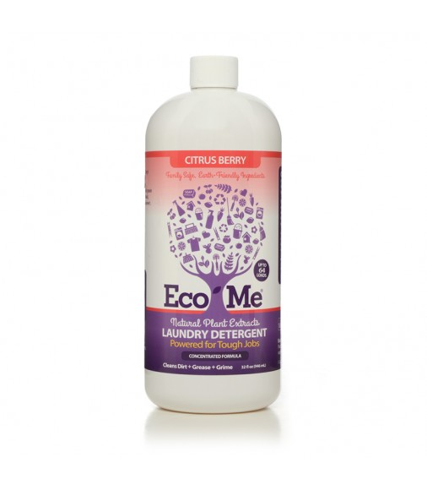
Here features one of the best natural liquid laundry detergents that is greatly pure in its composition. Although it is extremely tough on stubborn stains and dirt, it remains a safe, gentle, and best laundry detergent for sensitive skins. Even though it is fragrance-free, it was carefully formulated by experts to leave your laundry room with fresh and clean smell. This detergent is made from natural plant-based ingredients. Yet it is of great standard when it has to do with cleaning. It does not only smells great, it also assist you in saving your money.
Pros:
- Has natural and fresh scents;
- Perfect for those with sensitive skins;
- Free from phosphate, chlorine, and formaldehyde;
- Available in great natural scent;
- No dyes and colourants; and
- Highly effective in cleaning and removing stains.
Cons:
- It is not the best for those in search of a strong smell.
Customer reviews
It features a 4.0/5 stars rating in Laundry detergent reviews on Amazon. In addition, it also features several top customer reviews and a few critical customer reviews.
Several consumers attest that they decided to give this detergent a try due to the simplicity in its formulation and ingredients. Nevertheless, it worked up to their expectations as it operated in keeping their laundry room with a fresh smell and combatted all stains on their clothing. Thus they recommend this product for anyone who wants something that will work well in whole.
Nevertheless, some few customers reported negative that this product merits only 3/5 stars as it is decent but has some issues they do not appreciate. They complain of it not being as great in stain removal as advertised. However, they appreciate its simplicity and nice scent coming from natural plant sources.
Reviews of liquid Laundry detergent: Seventh Generation Natural laundry detergent
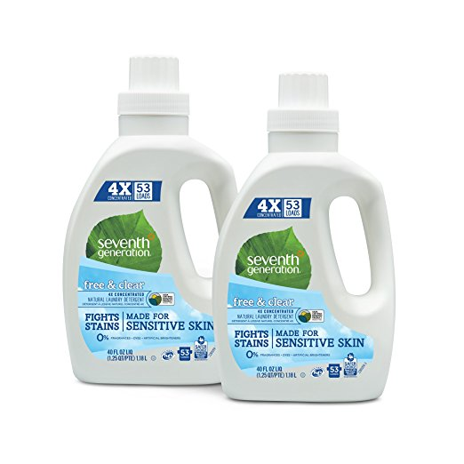
Featuring here is another best liquid laundry detergent for sensitive skin that is extremely hash on stains but very gentle and soft to your world. With no synthetic fragrances, optical brighteners, dyes, this is an outstanding natural laundry detergent that offers to you very great results in high efficient and standard washing machines. It works best I just all water temperatures thanks to its special formulation by experts in the domain. It is made with plant based premium ingredients. It is one of the best USDA Certified Biobased Product of 97%.
Pros:
- Dye-free;
- Synthetic fragrance-free;
- Works in all temperatures;
- Enzymes lift stubborn stains; and
- Reliable.
Cons:
- None.
Customer reviews
This natural laundry detergent is highly starred and appreciated by it consumers in laundry detergent reviews over the net.
Some customers highly appreciate this detergent for its simplicity in its ingredients and its natural scent. They also attest that they have highly sensitive skins and this product did well for them. They were also highly impressed that even after washing their cloths the detergent keeps on with its appealing smell. Thus they definitely recommend this product to anyone who has a highly sensitive skin and needs the best natural laundry detergent.
Nevertheless, some other few customers reported negatively as they were disappointed with this so called natural laundry detergent. They complained that it contains sodium lauryl sulfate which is one of the skin irritants. For this reason, they do not agree with it being a natural laundry detergent so do not recommend it for people with highly sensitive skins. However, they appreciate the other qualities of this laundry detergent like its cleaning ability and fresh scent it offers.
Reviews of liquid laundry detergents: OxiClean Fresh Scent Liquid Laundry Detergent
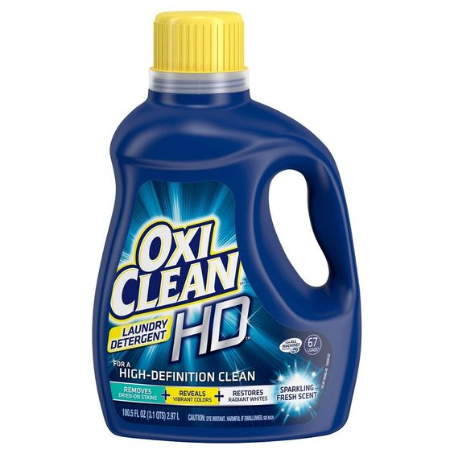
The OxiClean is in possession of unimaginable stain fighting force. It saves much time as all the stains on your cloths are immediately removed not long from the time they encounter this powerful laundry detergent. It prevents your cloth’s colours from fading and gives your clothes an appealing and shiny look. It restores the initial white colours of your cloths. It is highly credited for removing food and dirt stains.
Pros:
- Powerful stain and dirt fighter;
- Restores white loads; and
- Strengthen cloth fibres.
Cons:
- It comes over filled.
Customer reviews
It is stared 4.5/5 in Amazon for it efficiency when it has to do with dirt and stain removal. It also features several positive customer reviews alongside few negative ones.
Several customers class OxiClean as a miracle detergent attesting that it meets more than their expectations. They also attest that it keeps whites white. So many are happy with its ability to strengthen cloth fibres thus making them last for longer periods. Some appreciate its smell and attest that this is the best liquid laundry detergent they have used so far.
Nevertheless, it also has its draw back as some customers complain of it spilling when opened for the first time. However, these customers appreciate its efficiency and think with a little touch, this laundry detergent will turn to be the best in the market.
Reviews of liquid laundry detergent: Downy Unstoppables In-Wash Scent Booster Beads
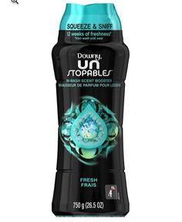
Its name says just everything you need to know about it. It is really unstoppable when it comes to the removal of stains and dirt in your favourite clothes. It gives then a pretty nice fresh scent. Worth noting is that from wash until wear, the downy unstoppable offers your precious clothes up to 12 weeks of full freshness from the very day you wash it until you wear. It was formulated professionally to work well in any kind of washing machine yet still being highly effective. It can be used for all colours and fabrics without any issues. To every load of laundry, whether it’s personal or for the whole family, it has the ability of adding long lasting freshness. It should be poured in little quantities or large ones depending on the load that you have before laundry and later add your cloths. You should also add fabric softener and that will be all for a great washing experience. Its essential ingredients include perfume dispersant, dye, and perfume. It is HE compatible. It is not meant to be swallowed and should be kept out of the reach of children. If swallowed, a glass of water should be taken. In cases of contact with the eye, it should be flushed with clean water.
Pros:
- Long lasting fresh scent of 12 weeks;
- Highly efficient in cleaning;
- Economical; and
- Easily dissolves.
Cons:
- None.
Customer reviews
It is starred 4.7/5 by amazon customers. It is highly appreciated and loved for its cleaning ability and awesome scent booster by several customers who previously used it and those still using it. Several customers appreciate its affordability.
However, some few customers although they attest that it is efficient, still find that it is expensive.
Reviews of liquid laundry detergent: Lysol laundry Sanitizer Additive
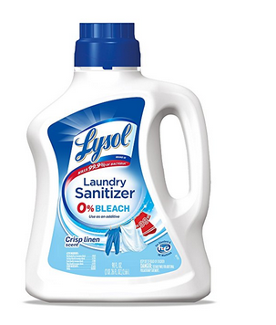
Here comes one of the best liquid laundry detergents that was carefully formulated to be added to rinse cycle. It is highly efficient in killing about 99.9% of bacterial. It eliminates all possible infections that you can have from clothing. The main bacterial that it eliminates are Klebsiella pneumonia, and Staphylococcus Aureus. Even in cold water, it works extremely well and contains 0% bleach. It works quite well in all kinds of standard and HE washing machines. There are certain laundry loads such as those of your children, as well as house hold sport wears that you want to eliminate bacterial from them. Normal detergents on their own do not always eliminate all bacteria, so this product should be taken as your solution. It should be noted that there exist certain bacteria from food and other sources that can survive the normal wash circle. Thus you need something much stronger to eliminate them. Lysol does this and at the same time remains gentle on most fabrics.
Pros:
- Perfectly cleans and eliminates bacterial from under wears;
- Eliminates bacterial from sport wears; and
- Economical.
Cons:
- None.
Customer reviews
It is averagely starred 4.5/5 by amazon customers for its effectiveness. There are several of her consumers who are highly delighted to have encountered the Lysol as they attest that it is a must have. They attest that it gets rid of all the funky smell caused by bacterial on their bathing towels and clothes. In addition, several customers affirm that it made up to their expectations.
Liquid detergent reviews: TYLER Glamorous Wash, Diva
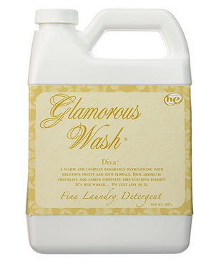
Here comes another best liquid laundry detergent that can be used for both hand washing and machine washing. Although it was formulated to act harshly on all stains and dirt it comes across, it still acts gently to the delicate and special fabrics of your cloths. With the glamorous you can perfectly clean all your fine fabrics, linens, and lingerie.
Pros:
- It is harsh on stains and dirt;
- It is gentle to the fabric of clothes; and
- It is economical.
Cons:
- An overpowering scent.
Customer reviews
It is averagely starred 4.5/5 by amazon customers. Several customers appreciate its long lasting and overpowering scent while some do not appreciate it. Nevertheless, its cleaning capacity is highly loved by all. So many customers reported that they will never leave it to go back to that they were previously using because the glamorous made it up to their expectations.
Liquid detergent reviews: Febreze In-Wash Laundry Odor Eliminator Detergent 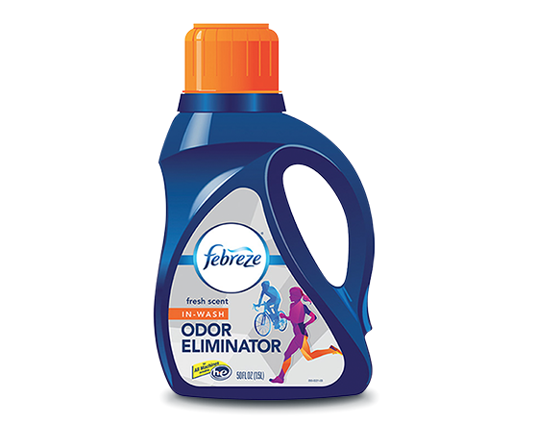
Several laundry detergents even after use are unable to eliminate the bad odours in clothes. With the febreze, it is not the case. It guarantees you efficiency in terms of odour elimination and stain removal. You can be sure that with febreze all stains on your clothes will be eliminated just in one wash. It features 3 times more freshening power when compared to its competitors. It goes well in all types of washing machines, even the high efficiency machines. It does not masks odours as it is the case with several other detergents. It is completely safe to use with all detergents, bleaches, soaps, laundry additives, and fabric softeners. Its excellent professional-strength formula is highly reputed for removing all kinds of smells that are caused by sports, pets, cooking, grease, perspiration, mildew and smoking.
Pros:
- Odour removal;
- Freshener; and
- Good smell.
Cons:
- Breaks when shipped.
Customer reviews
It is averagely starred 4.4/5 by amazon customers. Several amazon customers upon using this liquid laundry detergent testified that their washing experience was raised to the highest level with it. They were also highly pleased with its ability to clean their clothes, remove the headiest stains and leave their clothes free from unbearable odours.
Liquid detergent reviews: OUT ProWash Workwear Odor Eliminate Detergent
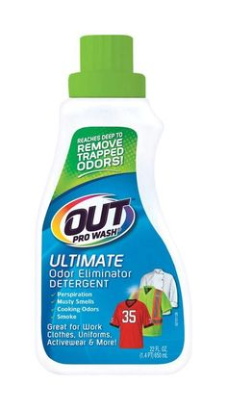
Even if your clothes are having the toughest of workplace odours, there is no need to worry as long as OUT PRO WASH is in the market. It was carefully formulated to combat the headiest odours in your clothes. For this task, it reaches really deep. It was formulated and fabricated in the United States. It removes odours such as musty smells, cooking smells, perspiration, and pet odours. Worth noting is that it does all these without sacrificing your clothes’ fabric. It was tested and proven to be suitable for use in cleaning and removing odours on your uniform, work clothes, microfiber, active wear, towels, and pet bedding. It can likely be used as a detergent or a detergent booster for the main detergent. When used in both cases, it yields the best of results. It is suitable for all washing fabric and all types of washing machines.
Pros:
- Works best for all washable fabrics;
- Eliminates unbearable odours;
- Can be used safely in all washing machines; and
- Can be used as a detergent or a detergent booster.
Cons:
- Works but costly.
Customer reviews
It is averagely starred 4.1/5 by amazon customers who have and are still using it. Several customers working from oil to gasoil stations are satisfied with it as it completely removes all the unpleasant smells each evening they use it to wash. Thus fantastic when it comes to odour and stain elimination. It removes just all odours even to that of the smelly tap water. Nevertheless, some few customers although they were highly impressed by its odour removal capacity complained that it takes more than one wash for all the odours to be removed.
Liquid detergent reviews: All Free and Clear
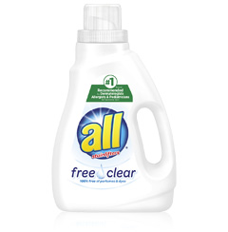
Here comes another dye-and-perfume free natural liquid detergent that has recently gained popularity thanks to its excellent results. It has a strong scent which is not strange since it was made with natural products. It has no synthetics to keel its natural odour. What is essential is that its natural raw smell is not transferred into laundry. So there is no need to worry. Nevertheless, its performance is unquestionable. It keeps all your clothes clean as it removes all heady stains and freshens them for long term use. Just as its name implies, it leaves up to all your expectations when it has to do with laundry. There is just no virtually left scent behind.
Pros:
- It is naturally made;
- It cleans very well; and
- It leaves no scent behind.
Cons:
- Scalp issues.
Customer reviews
It is averagely starred 4.3/5 by amazon customers. It also features several positive customer reviews alongside few negatives ones. Several customers after using this detergent concluded it is ideal for anyone who suffers greatly from allergic conditions. Others were pleased with it for getting their hair completely clean.
Liquid detergent reviews: Tide original
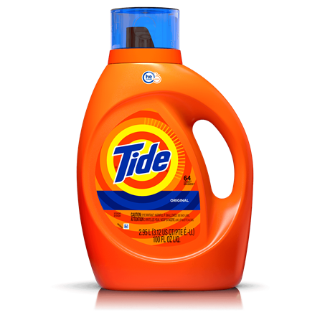
Tide liquid detergents were leaders in the world’s market for several years. This was merely because of the highly efficient formulations that their manufacturers adopted. For over 68 years, the Tide Original has been the best seller in the U.S. It is outstanding in terms of scent, cleaning ability, stain combatting, and money value. It is only behind the Persil previously reviewed that the Tide Original came behind. But in other categories it was outstanding and remained leader. Tide is as well one of the best sellers on amazon. It is highly suitable for high efficiency washers. Although other detergents competing with the Tide Original may seem less expensive, it should be noted that Tide surpasses most of them as much as 14% in everything. After laundry, you can be sure that you won’t be left with any other stain after you must have used Tide Original. It freshens your clothes and gives them a pretty nice smell of cleanliness. In some parts of America today, when we talk of cleanliness, what comes to the mind of many is the Tide liquid detergent.
Pros:
- Great cleaning ability;
- Clothe freshener;
- Stain removal;
- Best seller; and
- Economical.
Cons:
- None.
Customer reviews
It is averagely starred 4.1/5 by amazon customers for its effectiveness. Several customers find that it is a great product with a great price. They attest that it properly cleans all their clothes just as the expected. So many were pleased with its ability to remove even the stubbornness stains. Nevertheless, several customers complained that it does not work exactly as it is advertised.
Liquid detergent reviews: Tide liquid laundry detergent Smart Pouch
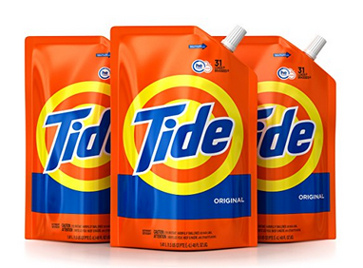
Here comes another tide liquid detergent that cleans 6 times the half of the normal time you will go with some other different detergent. It comes in an easy to use pouch that uses 60% less packaging. With it, you are able to reuse your empty tide bottle. It features brilliant cleaning abilities. It was formulated to always leave behind a freshening scent and appealing look on your clothes. It was carefully designed to work best in high efficiency washing machines. It has an original scent which is formulated with HE Turbo Clean Technology for up to 6 times the cleaning power in half the normal time as previously mentioned. It comes in revolutionary Tide pouches.
Pros:
- Original scent;
- HE Turbo Clean;
- 98 Loads; and
- Pack of three 48 oz.
Cons:
- None.
Customer reviews
This tide liquid detergent is averagely starred 4.7/5 by her customers on Amazon for its efficiency and effectiveness. Several customers attested their satisfaction for using the Tide. They were happy for the way that it cleaned their loads. They appreciated its stain removal ability. They found its package easy to use that they referred to it as an easy to refill packaging.
Liquid detergent reviews: Tide Free and Gentle High Efficiency Liquid Laundry Detergent
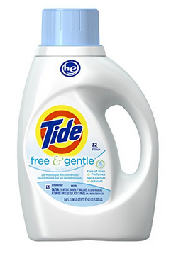
This is an excellent hypoallergenic tide liquid detergent that is highly gentle on your skin. Just a single dose of this tide liquid detergent will do the work that 6 doses of another detergent can do. This is to say it is highly concentrated and harsh on stains yet gentle to your skin and enhances your clothes rightly. It is completely free of dyes and perfumes. For the past years, it has gained the reputation of a good stain and dirt removal. Although it is harsh on stains, it enhances your clothes’ fibres and gives them a long lasting ability. Although it is highly concentrated, it easily dissolves in water.
Pros:
- Gentle on the skin;
- Harsh on stains;
- Removes all dirt;
- Constituents are natural;
- Eco-friendly; and
- Economical.
Cons:
- None.
Customer reviews
It is averagely starred 4.5/5 by amazon customers for its efficiency. In liquid detergent laundry reviews in amazon, this product features absolutely no negative customer reviews. This is to say that it is highly effective and works to meet all the expectations of her customers. Several customers attested of their joy in using this product which is gentle to the skin but harsh on dirt and stains. They thereby recommend it for anyone who needs the best liquid laundry detergent.
Liquid detergent reviews: The Tide Plus Downy HE Turbo Clean liquid laundry detergent
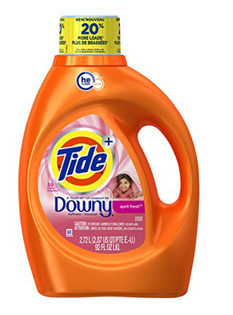
This Tide liquid detergent with April Fresh Scent offers the brilliant clean that you have ever longed for. It does not tamper with the fabric of your favourite clothes, it merely enhances them and increases their durability. It offers your clothes a shiny appearance and pretty nice smell. More to that, it features additional pearls that leave behind a long lasting, pleasant and comfortable scent. This nice Tide liquid detergent is highly recommended by leading High Efficiency washing machine manufacturers. It was carefully turbo-charged formulated to quick collapse suds and also target all forms of stains whether tough or not for efficient removal. It does not operate like other HE compatible laundry detergents that often slow machines down with over-sudsing.
Pros:
- It easily dissolves;
- It is ideal for HE washing machines;
- It removes the toughest stains; and
- Allows clothes with a pretty nice smell.
Cons:
- None.
Customer reviews
It is averagely starred 4.5/5 by amazon customers for its effectiveness. It features merely no significant negative customer reviews as all customers are high impressed with its functioning ability. They attest that since they purchased it, it has been working up to their expectations. Several others are very happy for its ability to remove stains just as it is being advertised. That is it removes the toughest stains without allowing anyone behind. Some other customers find that it is even gentler on the baby’s skin than the other advertised baby laundry detergents.
Liquid detergent reviews: Tide PurClean Plant-based Laundry detergent
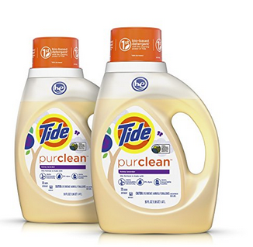
Here comes an interesting bio-based detergent that features the amazing cleaning power of Tide. It was cautiously formulated to be non-toxic to the nature. It is a USDA certified Tide liquid detergent. In its constituent, it was designed to be free of dyes, phosphates and chlorine. It was designed to be compatible for both high efficiency and normal washing machines. It has a honey lavender scent. It represents the first bio-based liquid detergent that has the cleaning power that everyone is expecting from Tide that has been a leader for so many years. It is not surprising that tide has been on a sustainable journey for several years and has merely taken another step with this pretty nice and efficient bio-based liquid laundry detergent.
Pros:
- Bio-based;
- USDA certified;
- Suitable for HE and normal washing machines; and
- It considerably eliminates the headiest stains on your clothes.
Cons:
- None.
Customer reviews
It is averagely starred 4/5 by her customers on amazon. It is highly loved by her consumers as they all are attesting of its efficiency thereby inviting others to join them in experiencing the best washing moments with this Tide liquid detergent. In addition to cleaning well, they find that it is a friendly detergent. Its pretty nice honey scent is highly appreciated by many that they can no longer sleeping without getting it on their bed sheet. Nevertheless, a few customers find that this laundry detergent from Tide doesn’t clean as it is advertised.
Liquid detergent reviews: The Tide ultra stainless release
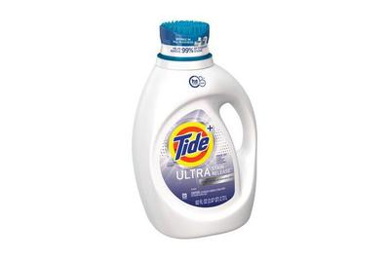
Here comes another excellent tide liquid detergent that combats tough stains and eliminates awful odours from your clothes. Just as its name indicates it works with an added step in front of its competitors. It has gained its solid reputation for several years now. One which can’t be argued. It works best for any normal load of laundry whether it is your personal clothing or that of the entire family. Worth noting is that it is fragrance-and-dye free. For this reason, you can be guaranteed that it will fully clean your clothes without leaving behind any scent and won’t also break the bank.
Pros:
- Stain remover;
- Complete dirt extinguisher;
- Eco-friendly liquid detergent;
- Dye-and-fragrance free; and
- Affordable.
Cons:
- None.
Customer reviews
The Tide Utra stainless release is averagely starred 5/5 by her amazon customers. It features several positive customer reviews with not even a single negative customer review meaning all her customers are satisfied. All the customers attest that this is the best product that came their way since they began using liquid laundry detergents. For this reason, they are recommending it for all who are in search of the best washing experience with liquid laundry detergents. They were also happy as their washing time was greatly reduced by this detergent. Some other customers were delighted with its ability to remove odours and freshen their clothes. Nevertheless, some few customers although were happy that this product works efficiently, still found that it was overpriced.

